**Zabbix Integrations**

**ServiceNow**

<http://zabbix.com/integrations/servicenow>

This template is for Zabbix version: 7.0

Source: <https://git.zabbix.com/projects/ZBX/repos/zabbix/browse/templates/media/servicenow?at=release/7.0>

This guide describes how to integrate Zabbix 7.0 installation with ServiceNow using the Zabbix webhook feature. This guide provides instructions on setting up a media type, a user, and an action in Zabbix.

Please note that recovery and update operations and ServiceNow's custom fields are supported only for trigger-based events.

**Setting up ServiceNow**

1. First, [create](https://docs.servicenow.com/bundle/orlando-platform-administration/page/administer/users-and-groups/task/t_CreateAUser.html) a service user for creating incidents.

2. [Assign](https://docs.servicenow.com/bundle/orlando-platform-administration/page/administer/users-and-groups/task/t_AssignARoleToAUser.html) to the newly created user the following roles:

* rest_api_explorer
* sn_incident_write

**Setting up webhook in Zabbix**

1. Before setting up a ServiceNow Webhook, it is recommended to set up a global macro "{$ZABBIX.URL}" containing a URL to the Zabbix frontend.

As an example, this macro can be used to populate ServiceNow's custom field with a URL to event info or graph.

[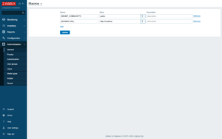](https://git.zabbix.com/projects/ZBX/repos/zabbix/browse/templates/media/servicenow/images/1.png)

2. In the "*Administration -> Media types*" section, import the [media_servicenow.yaml](https://git.zabbix.com/projects/ZBX/repos/zabbix/browse/templates/media/servicenow/media_servicenow.yaml)

3. Open the newly added **ServiceNow** media type and replace all *<PLACEHOLDERS>* with your values.  
The following parameters are required:  
**servicenow_user** - login of the ServiceNow user created earlier  
**servicenow_password** - user's password

To export information into a ServiceNow custom field, add a parameter with the custom field ID as a key (if you need help finding custom field ID, see [this page](https://community.servicenow.com/community?id=community_question&sys_id=c8aa472ddb5cdbc01dcaf3231f96190a) in ServiceNow community).  
[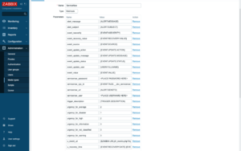](https://git.zabbix.com/projects/ZBX/repos/zabbix/browse/templates/media/servicenow/images/2.png)

**Notes:**

* ServiceNow instance must be in the same timezone as your Zabbix server.
* For fields with "Date/time" type, parameter values must be separated via space (example: "{EVENT.DATE} {EVENT.TIME}"). See the ServiceNow [documentation](https://docs.servicenow.com/bundle/orlando-platform-administration/page/administer/time/reference/r_FormatDateAndTimeFields.html) for details about the date and time format.
* Values of the parameters with date only will be converted from Zabbix format "yyyy.MM.dd" to "yyyy-MM-dd" for compatibility with the ServiceNow's API. These parameters must contain only macros that return the date (e.g. {EVENT.DATE} or {EVENT.RECOVERY.DATE}).
* If you don't want to duplicate information in a description field and the custom fields, modify the message templates for *Problem*, *Problem recovery* and *Problem update* types in the *Message templates* tab.  
  [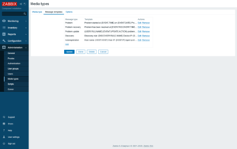](https://git.zabbix.com/projects/ZBX/repos/zabbix/browse/templates/media/servicenow/images/3.png)

4. Create a **Zabbix user** and add **Media** with the **ServiceNow** media type.  
The **Send to** field must contain the full URL of your ServiceNow instance (https://<INSTANCE>.service-now.com/).  
Make sure this user has access to all hosts for which you would like problem notifications to be converted into ServiceNow tasks.

For more information see [Zabbix](https://www.zabbix.com/documentation/7.0/manual/config/notifications) and [ServiceNow](https://docs.servicenow.com/) documentations.

**Ansible (AWX)**

<https://www.zabbix.com/integrations/ansible#event_driven_ansible>

This template is for Zabbix version: 7.0

Source: <https://git.zabbix.com/projects/ZBX/repos/zabbix/browse/templates/media/event_driven_ansible?at=release/7.0>

**Event-Driven Ansible webhook**

This guide describes how to integrate your Zabbix 7.0 installation with Event-Driven Ansible using the Zabbix webhook feature. This guide will provide instructions on setting up a media type, a user, and an action in Zabbix.

**Setting up Event-Driven Ansible Webhook**

1. Make sure you have the webhook plugin loaded from the standard ansible collection (ansible.eda.webhook) and use ansible-rulebook v0.11.0 and higher.

2. Create a rulebook and specify a webhook from the standard eda collection (ansible.eda.webhook) as the event source. Specify listen address and port.

3. Set necessary actions in the rules section. As an example you can use:

*---*

*- name: Zabbix Test rulebook*

*hosts: all*

*sources:*

*- ansible.eda.webhook:*

*host: 0.0.0.0*

*port: 5001*

*rules:*

*- name: debug*

*condition: event.payload is defined*

*action:*

*debug:*

4. For testing you can run ansible-rulebook with command:

*ansible-rulebook --rulebook test-rulebook.yml -i inventory.yml --verbose*

Note: before starting, make sure that the eda-server is running and you are in the eda-server virtual environment.

**Setting up Zabbix Webhook**

The configuration consists of a *media type* in Zabbix which will invoke a webhook to send alerts to Event-Driven Ansible. To utilize the media type, you need to create a Zabbix user to represent Event-Driven Ansible. Then, create an alert action to notify the user via this media type whenever a problem is detected.

Note: only trigger-based and only problem events are currently supported

Create the Event-Driven Ansible media type

1. In the *Alerts* menu section, select *Media types*.

2. Click on the **Import** button in the upper right corner.

[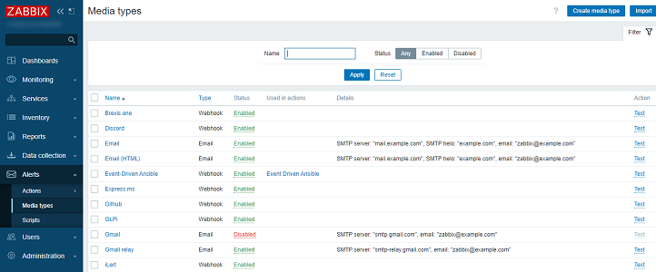](https://git.zabbix.com/projects/ZBX/repos/zabbix/browse/templates/media/event_driven_ansible/images/1.png)

3. Select the file [media_event_driven_ansible.yaml](https://git.zabbix.com/projects/ZBX/repos/zabbix/browse/templates/media/event_driven_ansible/media_event_driven_ansible.yaml) and press **Import** at the bottom.

**Create the Event-Driven Ansible user for alerting**

1. In the *Users* menu section, select *Users*.

2. Click on the **Create user** button in the upper right corner. Fill in the details of this new user.

[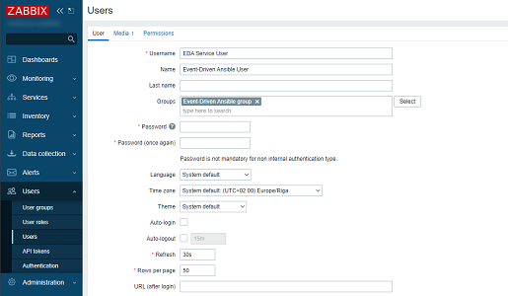](https://git.zabbix.com/projects/ZBX/repos/zabbix/browse/templates/media/event_driven_ansible/images/2.png)

Please note: To be notified of host problems this user must have at least read permissions for the given host.

3. Navigate to the **Media** tab and click on the **Add** button inside of the Media box.

4. Configure the media type:

* Set *Type* to *Event-Driven Ansible*.
* In the *Send to* field, specify the IP address and destination port in the format xxx.xxx.xxx.xxx:port.
* Press Add to save the media type.

[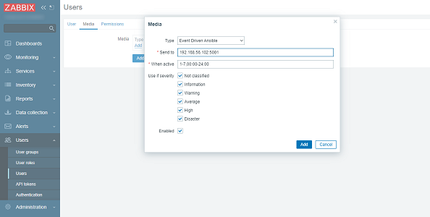](https://git.zabbix.com/projects/ZBX/repos/zabbix/browse/templates/media/event_driven_ansible/images/3.png)

5. Press Add in the User configuration form to save the user.

Note: Because each new rulebook requires a separate port, you must create a separate user for each rulebook, specifying the ip:port.

6. Use Event-Driven Ansible user in any [actions](https://www.zabbix.com/documentation/7.0/manual/config/notifications/action) of your choice.

[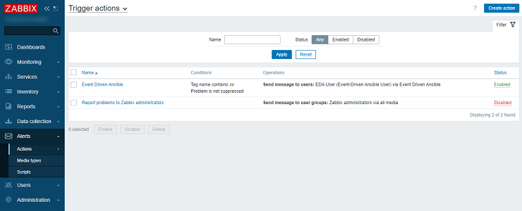](https://git.zabbix.com/projects/ZBX/repos/zabbix/browse/templates/media/event_driven_ansible/images/4.png)

7. Start getting alerts! You have made it!

For more information see [Zabbix](https://www.zabbix.com/documentation/7.0/manual/config/notifications), [Event-Driven Ansible](https://github.com/ansible/eda-server/blob/main/README.md) and [Ansible-Rulebook](https://ansible-rulebook.readthedocs.io/en/latest/getting_started.html) documentations.

Since we are using AWX instead of Ansible so we might need to deploy eda-server-operator.

<https://github.com/ansible/eda-server-operator>